Christmas Bird Count – December 30, 2023
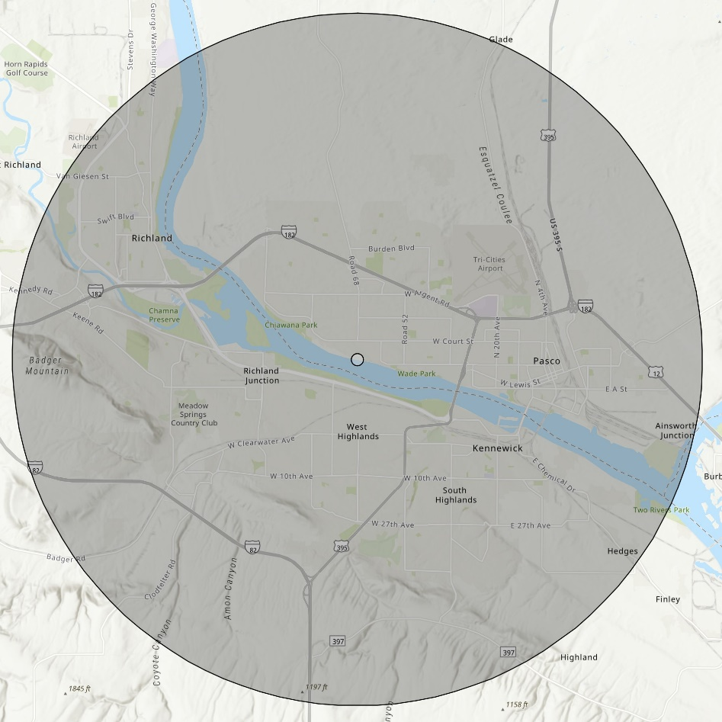
This year’s annual Christmas Bird Count will be held on Saturday, December 30th. The goal is to establish bird population trends within the attached count circle. Count teams are being formed and anyone can help. So, join in on the fun and contribute to science. You can simply count birds coming to your feeders, walk around your block, or survey an entire area within the count circle.
Although we have lost a lot of open land to housing developments, roads and industry, our count circle has abundant water where a variety of water birds and shorebirds can be found. We also have many open park areas that support a good population of upland birds. The count has been conducted in the Tri-Cities count circle since the 1960s and is a significant contributor to the local, regional, and national bird population data base.

We have divided the count circle into three sections. Lisa Hill (509-869-6715) is leading the Richland Team, Rich Barchet (509-430-0053) is leading the Kennewick Team, and Dana Ward (509-545-0627) is leading the Pasco Team. Starting this year, I, Bill LaFramboise (509-531-3768), will be the overall compiler. Please coordinate your efforts with one of the team leads to prevent overlap within the area or any one of us if you have questions about participating.

